Tree Worksheet

Binary Trees

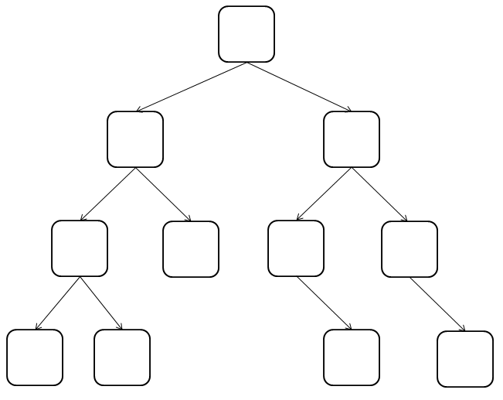
Insert the following numbers into this balanced tree:

1. 64
2. 23
3. 15

4. 79
5. 4
6. 67

7. 44
8. 99
9. 17

10. 72
11. 100

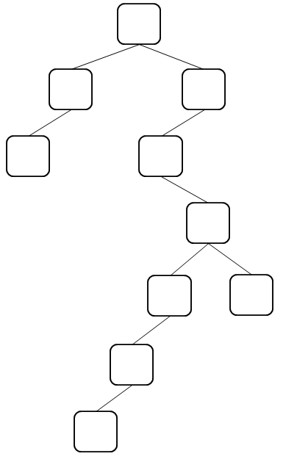

Insert the following numbers into this unbalanced tree. (Notice that though the data is the same, they’re in a different order than the first tree)

1. 17
2. 100
3. 23

4. 79
5. 67

6. 99
7. 72
8. 64

9. 15
10. 4
11. 44

